Jonathan Elder
8/26/2023
Assignment 1

Deliverables
You must submit a doc/pdf file with your answers.
Specifications

Question 1: (60 points)
Consider the following relational database schema consisting of the relation schemas:
movies (movie_id, director_id, movie_title, year, length_minutes, rating, domestic_sales, international_sales) movie_cast (movie_id, actor_id) directors (director_id, firstname, lastname, city_id, age) actors (actor_id, firstname, lastname, city_id, age) cities (city_id, city, state, country)
- Fetch all actor names with movies they worked on.
SELECT a.firstname AS actor_firstname, a.lastname AS actor_lastname, m.movie_title
FROM actors a
JOIN movie_cast mc ON a.actor_id = mc.actor_id
JOIN movies m ON mc.movie_id = m.movie_id;
- Fetch all director names with the city and state they are from.
SELECT d.firstname AS director_firstname, d.lastname AS director_lastname, c.city, c.state
FROM directors d
JOIN cities c ON d.city_id = c.city_id;
- List actor names, director names, and movies they worked on by their international sales in desc. order.

SELECT a.firstname AS actor_firstname, a.lastname AS actor_lastname,

CPSC
5
1
3
0

Assignment

1

d.firstname AS director_firstname, d.lastname AS director_lastname,
m.movie_title, m.international_sales
FROM actors a
JOIN movie_cast mc ON a.actor_id = mc.actor_id
JOIN movies m ON mc.movie_id = m.movie_id
JOIN directors d ON m.director_id = d.director_id
ORDER BY m.international_sales DESC;

Question 2: (20 points)

What is cross join? How is it different from natural join? Explain with one example.

A cross join will produce a “cartesian” product of two different tables. The resulting table will contain all the attributes of both tables, this will also include any duplicate columns. When producing a natural join, the resulting table will only keep one copy of the common column. So let’s consider an example using the schemas from the first question. Consider the tables “actors” and “directors” using a cross join:

SELECT * FROM actors CROSS JOIN directors;

The cross join produces all possible combinations of actors and directors, which will include any duplicates, while the natural join only returns rows where the "city_id" matches in both tables.
Natural Join:
SELECT * FROM actors NATURAL JOIN directors;

Question 3: (20 points)

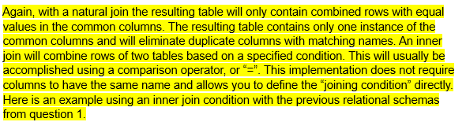
What is natural join? How is it different from inner join? Explain with one example.
INNER JOIN directors ON actors.city_id = directors.city_id;

